**Digital Marketing & E-commerce**

First sale 1994 (cds)

e-commerce is cheaper and more convenient

e-commerce – buy and sell goods online

physical

digital

software

digital marketing – reach consumers online

cost effective

reach more people

faster results

build customer relations

ads

social media

email

curiosity

analytical thinking

storytelling

build career through personal brand

agency vs in house

**Key takeaways**

Various technologies make digital marketing more cost-effective and adaptable than traditional marketing. Digital marketing tools also enable more advanced and targeted audience selection for marketing campaigns. However, these benefits come with some challenges. In a digital space that’s both crowded and noisy, it’s harder for a company’s brand and advertising to stand out. Marketing professionals must keep up with technological advances and customer behaviors that change rapidly.

Touchpoint

Journey map

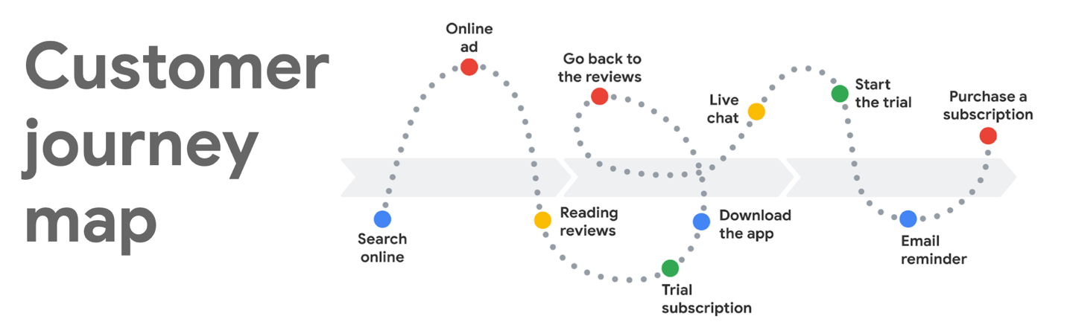

Market funnel: customer learn about brand to become loyal customers.

Awareness (known brand), consideration (check out brand), conversion (buy brand product), loyalty (only buy brand product)

Target audience: people most likely to buy your product

Lead: customer share personal info with brand

Metric: quant method to measure progress toward objective

Impressions (total amount time ad appear), reach (total # of unique individuals reached), frequency (how often ad appear)

Brand: how a business is perceived

Products or services: ex. Clothes or software

Brand equity: the value of 1 brand to other (comparison)

Media mix: combo of digital channels to reach goals and divide budgets

Paid media: digital promotion

Earned media: positive digital exposure through public

Owned media: brand that a business control

SEO: increase quantity and quality of traffic to a website (search listing)

SERP (search engine result page)

SEM (search engine marketing): paid ads

PPC (pay per click)

CPC (Cost per click)

Remarketing: target past people already interested in your brand

Social media market: posting brand on social media

Strategy, planning and publishing, listening and engagement, analytics and reporting, paid social media

Spam (junk mail)

Performance marketing: concrete info about customer into to refine marketing and sales

CLV (customer lifetime value)

ROAS (return on ad spend)

Key performance indicator (KPI): how successful a business goal is

Data analytics: monitor and evaluate data

Data storytelling: narrative, data, viz